Willamette TMDL Implementation Plan
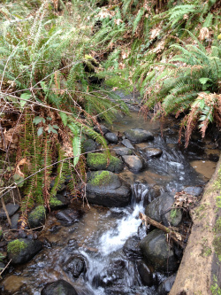
What is a TMDL?
The Oregon Department of Environmental Quality (DEQ) has determined the Total Maximum Daily Load (TMDL) of specific pollutants from local streams that can enter the Willamette River. Businesses are familiar with the limits on "end-of-pipe" or "point source" discharges and work with the City Pretreatment Program, the TMDL Program covers pollutants that enter streams through runoff from driveways, streets, roofs, lawns, and fields.
Why is this important? Whenever people create a city, town, cultivate fields, or change forests, the rivers and streams carry more sediment, oil, litter, feces, nitrogen, phosphorus, and other chemicals than normal. The increased amount of pollution affects aquatic life in the stream and changes its characteristics. Stream banks erode, stream bottoms change from gravel and sand to muck, invasive species grow along the banks, and algae increases. The TMDL helps to control the amount of pollutants ultimately entering the Willamette River.
You can help! Keep stormwater drains clear, notify the city if you see anyone dumping anything in a manhole or stream, and disposing of waste properly. Participate in the annual Hazardous Waste Collection Program held every May. Never use street drains for clean-up, chemicals, pet waste or anything other than rain water.

